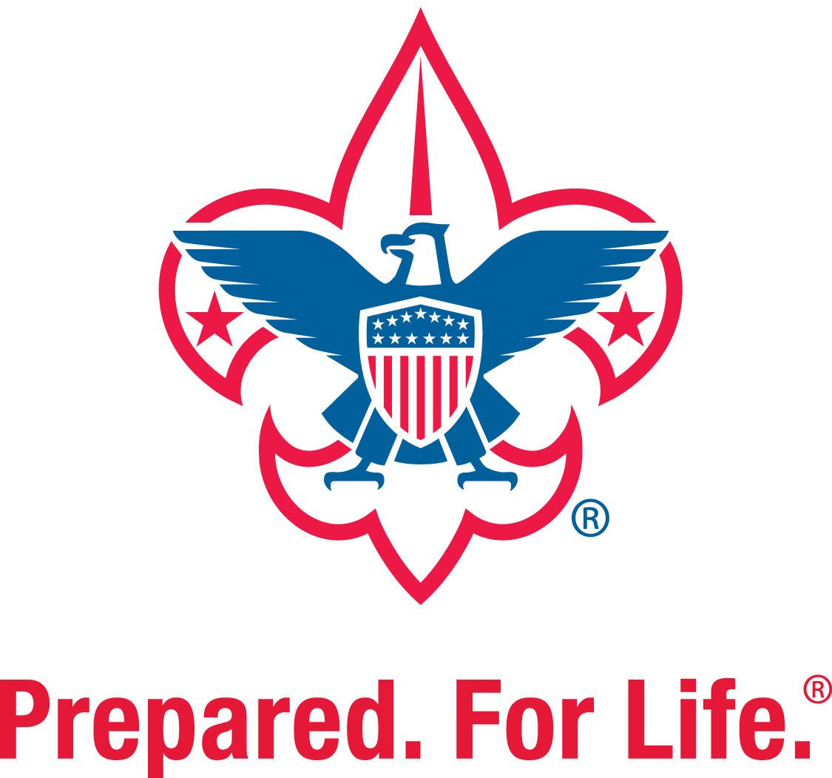

Troop 58
Davidson, North Carolina

New Merit Badge Counselor
Registration and Training

May 2019

Welcome to Troop 58!

We are thrilled to have you on board with Troop 58. As part of your new position within the troop an adult application as well as required training needs to be completed. This document details the requirements as well as how to access and complete them. Reach out to the Troop Committee Chair, Registration Chair, or Training Chair with any questions you may have.

It is recommended to complete the below requirements in chronological order and use the below summary as a checklist.

Requirement One: Youth Protection Training (YPT)
Method: Online
Frequency: Every 24 Months
Instructions: Pages 4 - 5
Details: It is the mission of Youth Protection volunteers and
professionals to work within the Boy Scouts of America to maintain a culture of Youth Protection awareness and safety. A certificate of completion will be generated upon completion of the course. This certificate needs to be submitted along with the Adult Application.

Requirement Two: Adult Application
Method: Paper Application
Frequency: Once
Instructions: If not already provided one, an application can obtained from
the Troop Committee Chair or Registration Chair.
Details: Return completed application, along with YPT certificate of
completion, to Registration Chair.

Requirement Three: Merit Badge Counselor Application
Method: Paper Application
Frequency: Initial sign up as counselor and with any/each change.
Instructions: Access the form on the Merit Badge Page of the troop website (https://www.gt58davidson.com/merit-badges) or navigate: Home -> Program -> Merit Badges).
Details: Return completed application, along with YPT certificate of
completion, to Registration Chair.

Requirement Four: BSA Health Form
Method: Paper Form
Frequency: Every 12 Months
Instructions: If not already provided one, the form can be accessed via the below link or Google BSA Health Form. https://filestore.scouting.org/filestore/HealthSafety/pdf/680-001_ABC.pdf
Details: Parts A and B are required for all participants. Part C is required if you will participate in an activity lasting longer than 72 hours (like summer camp). Note that Part C must be completed by a certified and licensed physician (MD, DO), nurse practitioner, or physician assistant. Return completed form to the Troop Health Form Coordinator.

Requirement Five: Troop 58 Adult Code of Conduct
Method: Paper Form
Frequency: Once
Instructions: The form is on Page 6 of this document. Print the form and return
completed and signed to Troop Committee Chair.
Details: This demonstrates the commitment from each adult leader to serve
as a positive role model and to live up to the Scout Oath, Law, Motto and Slogan.

Requirement Six: Merit Badge Counselor Training
Method: Online
Frequency: Once
Instructions: Pages 7 - 9
Details: Position specific training designed for Committee Members. This
course serves as an orientation to the position as well as how to effectively run and participate in a Committee Meeting.
How to Complete Youth Protection Training (YPT)

- Visit my.scouting.org and sign in to your account
  - Recommended browsers are Google Chrome for PC or Safari for Mac
  - “Forgot Username” and “Forgot Password” links available if needed

- On the opening page, select the Youth Protection logo 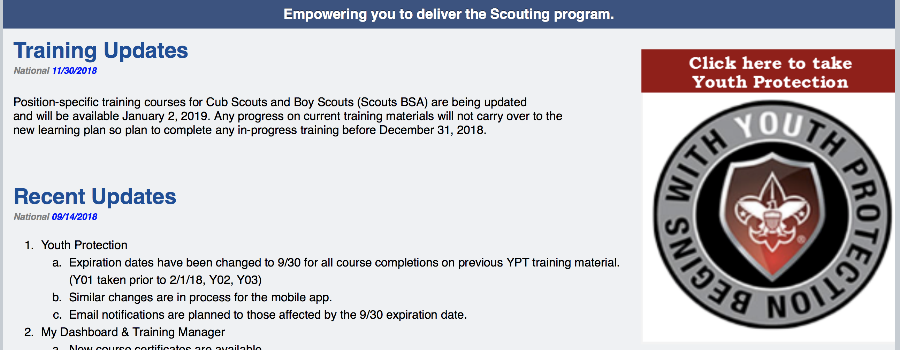

- A new window will open. Review the Opening video then scroll down and select “Add Plan”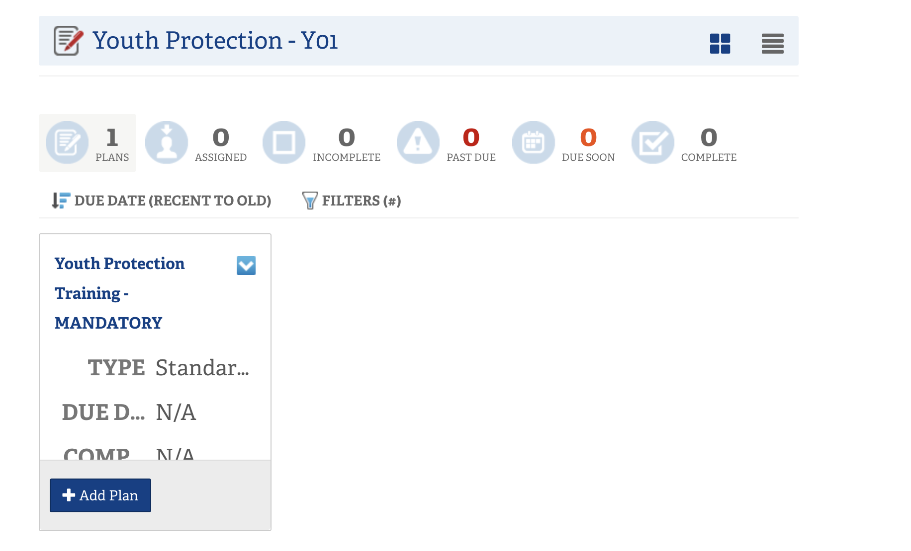
- Select “Youth Protection Training” to open the course
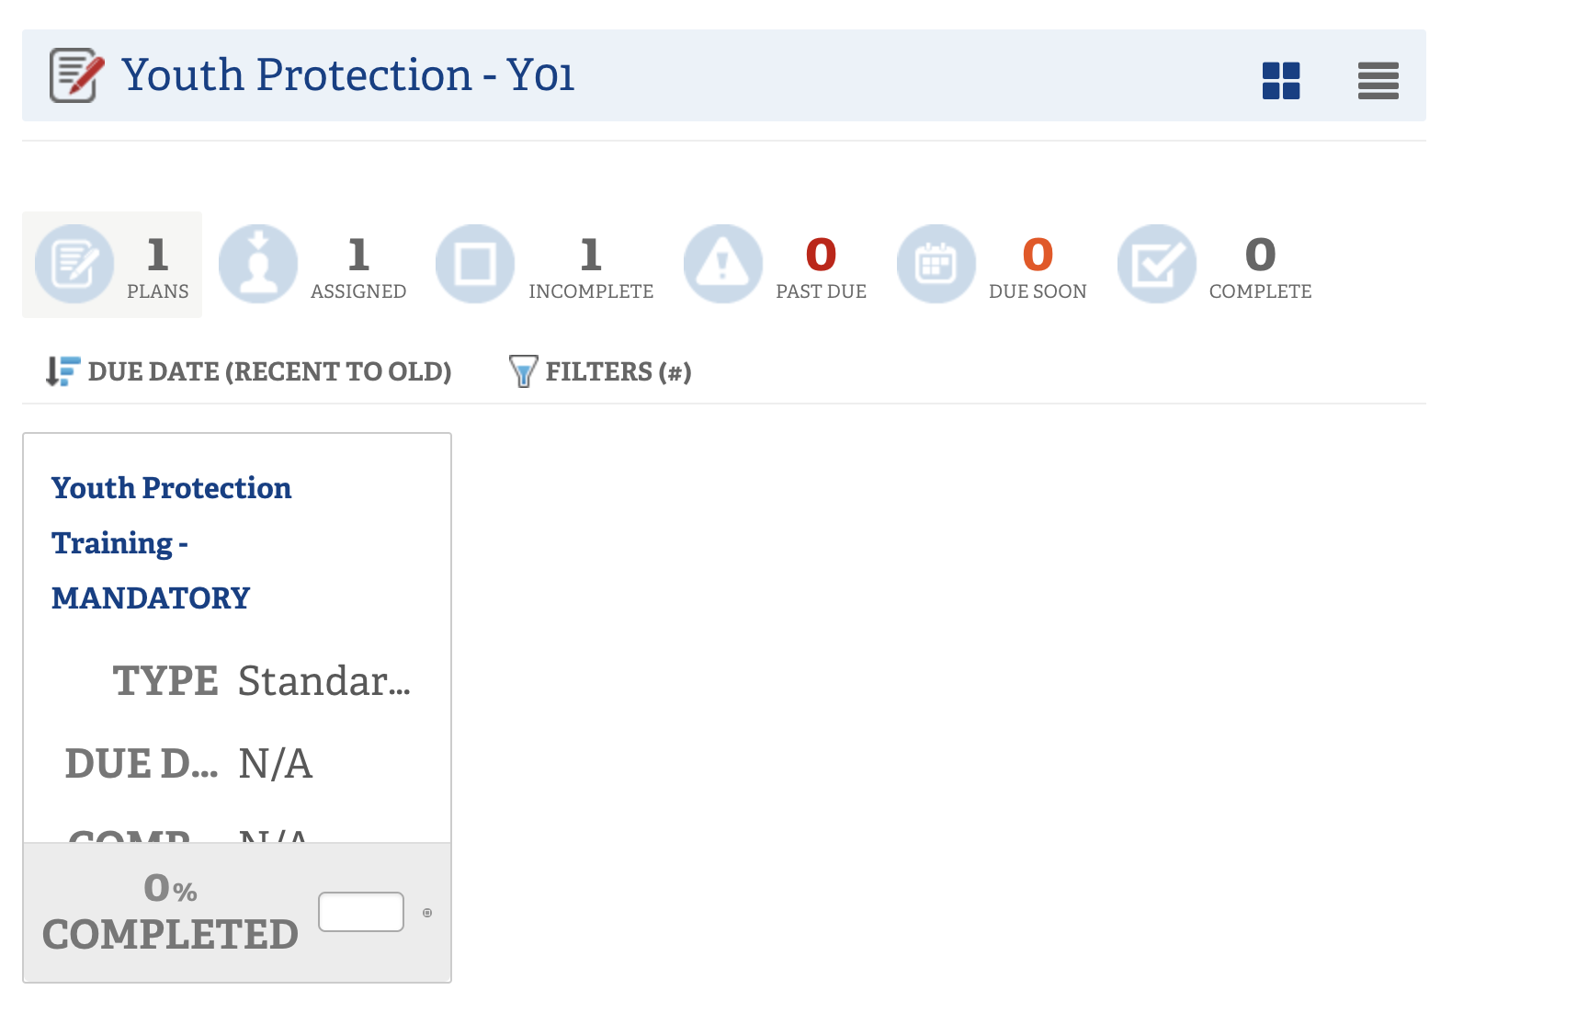

- Select “Launch Course” to open each module. All four need to be completed for full credit of Youth Protection Training

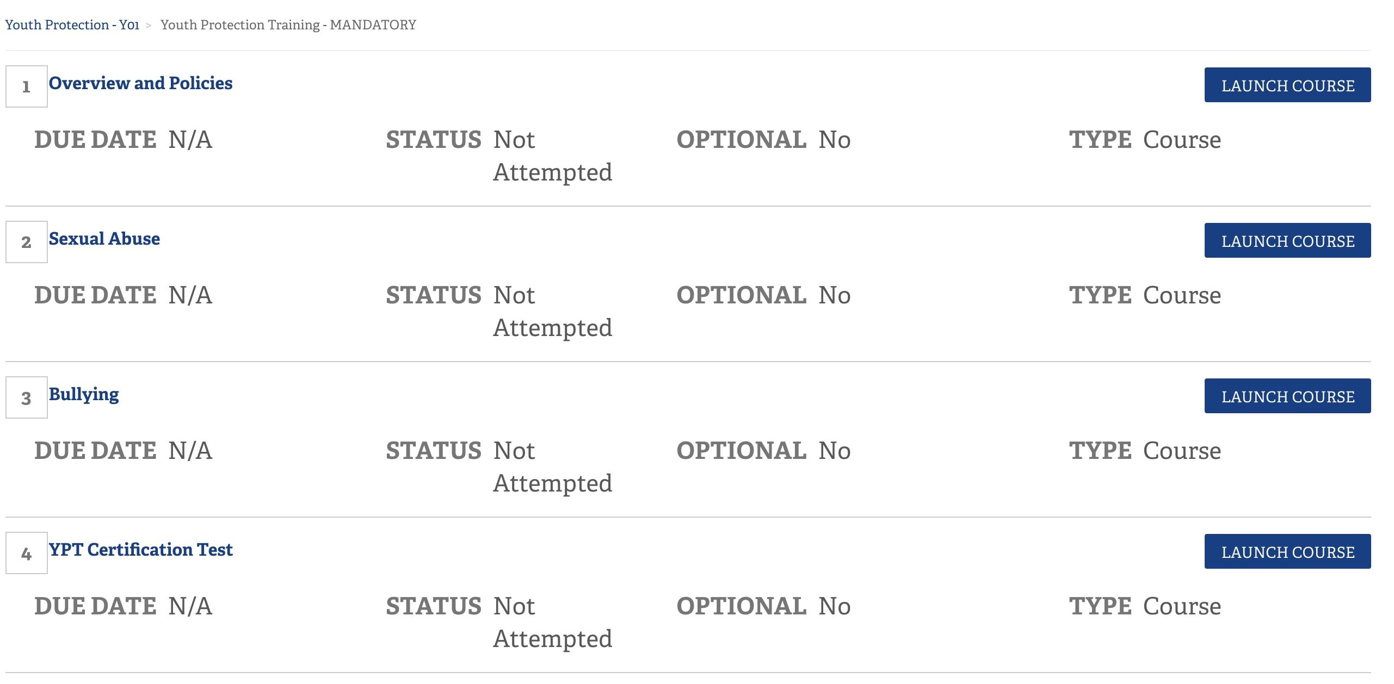

Troop 58 Adult Code of Conduct
All adults participating in Troop 58 activities serve as role models and leadership examples for our Scouts. Therefore, all of us are as accountable as our Scouts are for living up to the Scout Oath, Law, Motto and Slogan. We must also follow Scout adult leadership best practices. The following Adult Code of Conduct is our commitment by each adult leader and by each parent/guardian who will serve as an adult chaperone during the course of the program year. Any situation that is not explicitly covered by the code will be decided by the Troop Committee.

Initial Each Statement
- Adults registered as a Scout Leader must complete BSA Youth Protection Training, level specific
training, and will be familiar with the principles of the Guide to Safe Scouting (http://www.scouting.org/health- and-safety/gss).

- Non-uniformed adults serving as Chaperones during Scout activities must be familiar with the
principles of BSA Youth Protection (http://www.scouting.org/Training/Youth-Protection). Additionally, the Guide to Safe Scouting is available to any Troop Member as a reference guide.

- All Adults will follow the BSA policy of 2-Deep Leadership. At no time will one adult be alone with one
youth, other than their own child. Adults will not share bathroom facilities with Scouts. Separate usage times must be coordinated when dedicated facilities are not available.

- Drivers will not operate or hold mobile phones for talk, text, or navigation while driving during
Scouting Activities. When necessary, a passenger can assist with navigation or with holding mobile devices for navigation.

- Adults will abide by the law and will not purchase, possess or consume illegal drugs. Adults will not
possess or consume alcoholic beverages at Scout events. Adults will not use tobacco products in the presence of Scouts.

- Adults will set the standard for use of clean and kind language. Profanity, put-downs, sexual-related
comments, and verbal taunting will not be tolerated.

- Adults will behave in a safe manner. Unsafe behaviors will not be tolerated and include improper use
of knives or axes, improper use of sharp sticks, rope or other equipment, and playing with fire.

- Adults will abide by the underlying principle of never doing anything for a Scout that they can do themselves.
We allow Scouts to grow by practicing leadership and by learning from their mistakes. And while Scout skills are an important part of the program, what ultimately matters when our Scouts become adults is not whether they can use a map & compass, but whether they can offer leadership to others in tough situations; and can live by a code that centers on honest, honorable, and ethical behavior.

- The Troop Committee will review any incident as requested by a scout, a parent/guardian or adult
scout staff member or chaperone.

My signature below indicates that I agree to follow the Troop 58 Adult Code of Conduct.

Signature Print Name Date
Online Course Instructions: Merit Badge Counselor Training

- Visit my.scouting.org and sign in to your account
  - Recommended browsers are Google Chrome for PC or Safari for Mac
  - “Forgot Username” and “Forgot Password” links available if needed

- Select “Menu” in the upper left corner
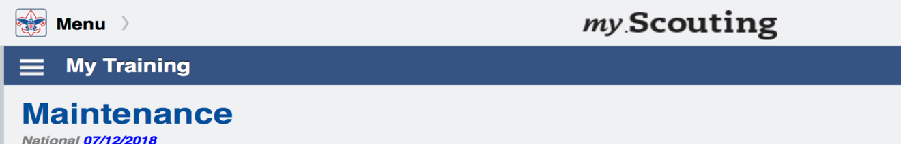

- Select “My Dashboard” in the drop down
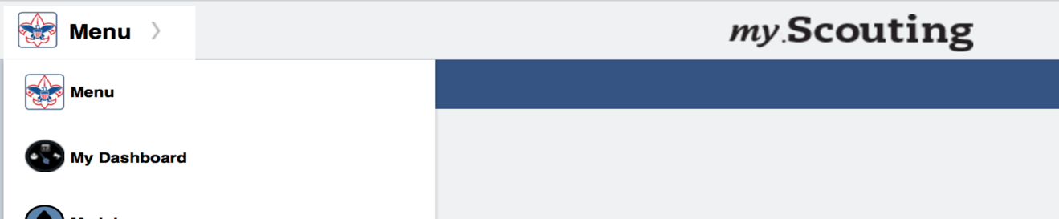

- Select “Training Center”
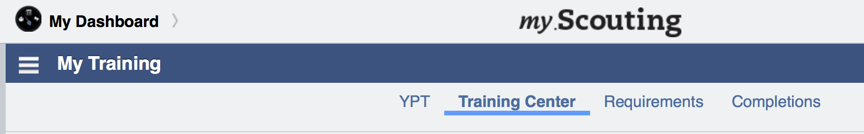

- Select “Scouts, BSA” from the list of programs
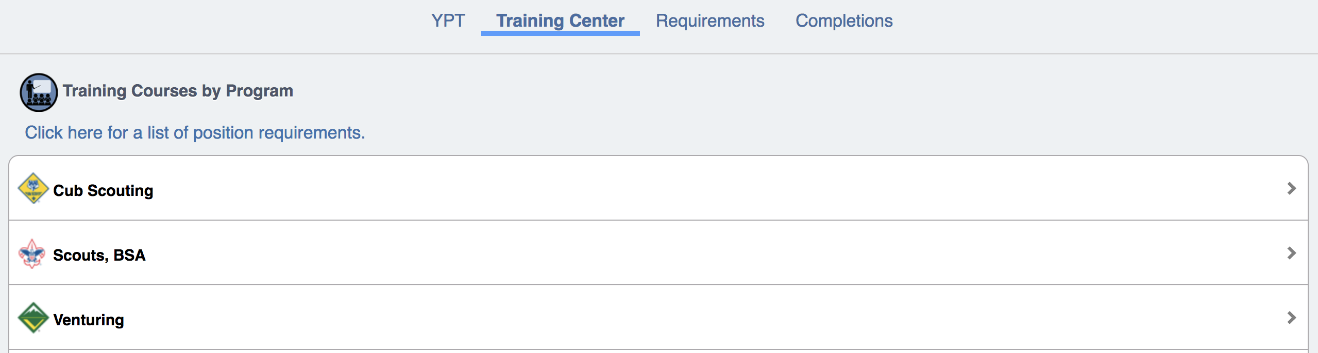

- New Window will open…scroll down and under “Merit Badge Counselor Training”, select “Add Plan”
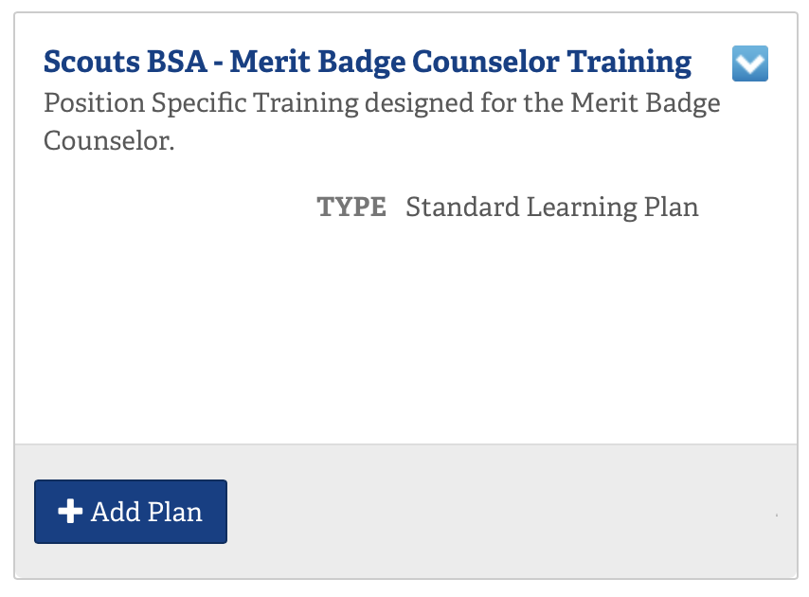

- Select “Merit Badge Counselor Training”
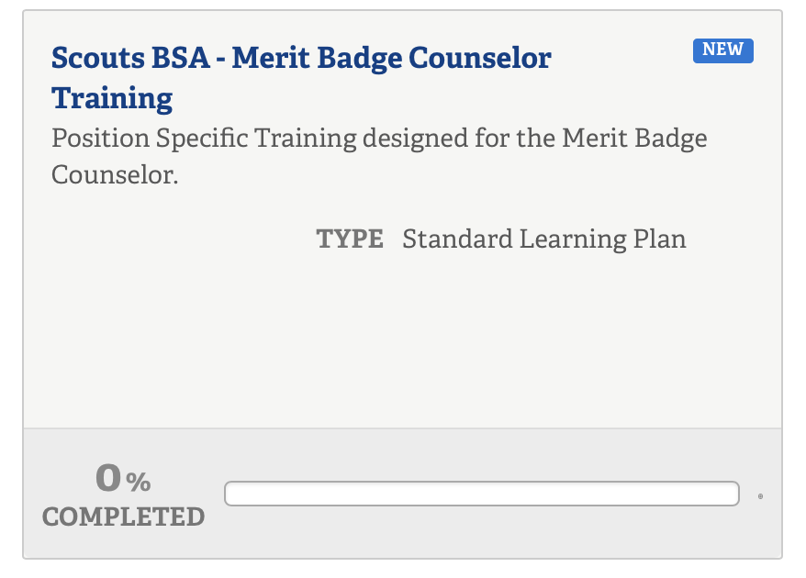

- Select each individual course. There are two:
“Before the First Meeting”; “Position Trained”
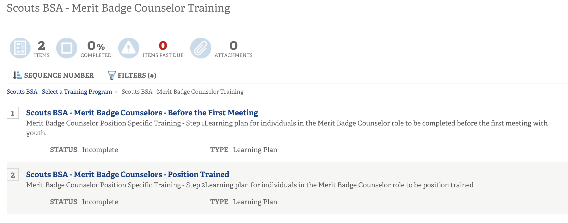

- Within each of the two courses, select “Launch Course” to complete each listed module. Each course has multiple individual modules - all need to be completed for full credit.
